MDM END USER DOCUMENT FOR iOS
STEP 1:
Open a Play Store in your Mobile Phone Search for Intune Company Portal and click GET.

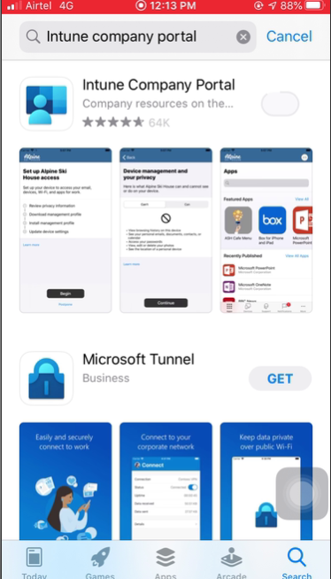

STEP 2:
Click on Open after the installation completed.

STEP 3:
Click On Sign in Company Portal.

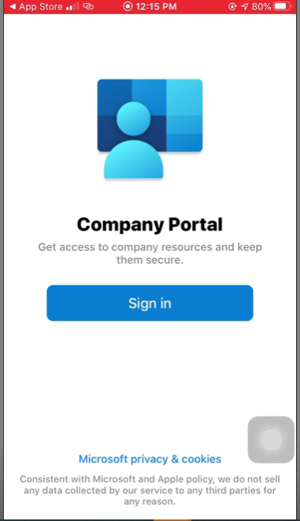

STEP 4:
Kindly enter your username.

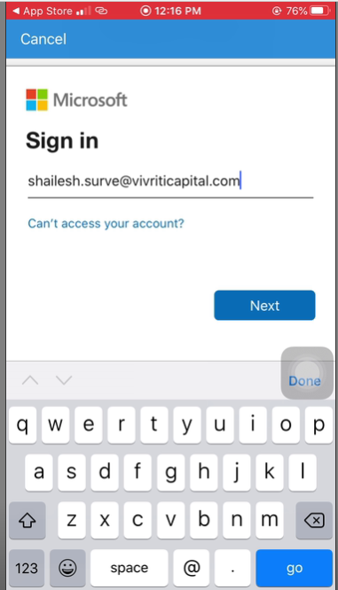

STEP 5:
Kindly enter your password.

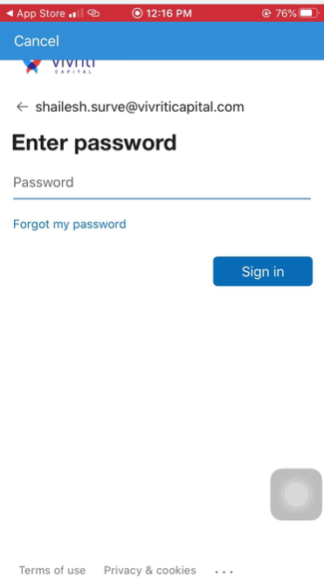

STEP 6:
Click on Ok to allow Notifications

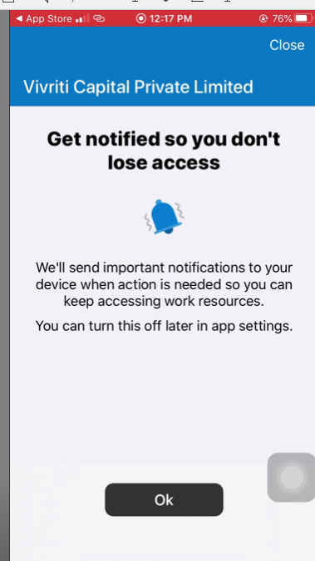

STEP 7;
Click on Ok to allow Notifications

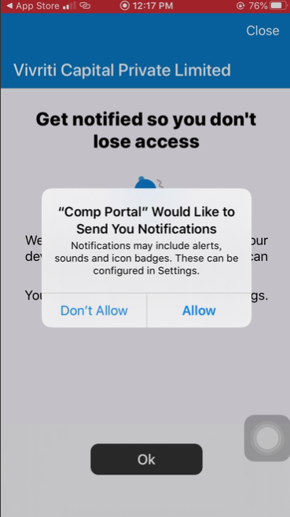

STEP 8:
Click On Begin to Create the Work Profile.

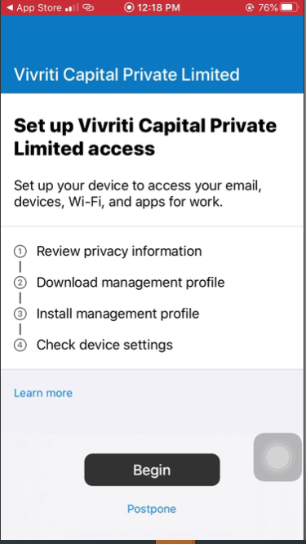

STEP 9:
View the settings and Click on Continue.

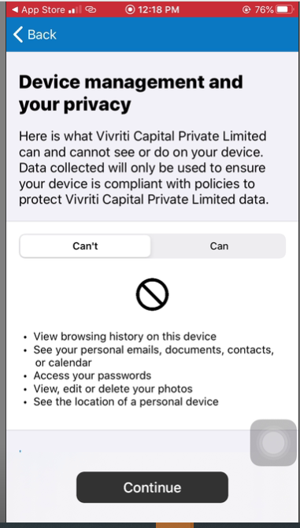

STEP 10:
Click On Allow and continue to set up the work profile.

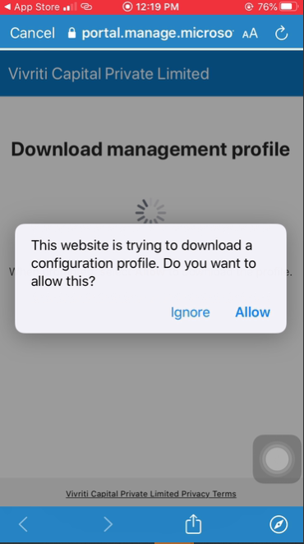

STEP 11:
Go to your settings and select the Profile Downloaded.
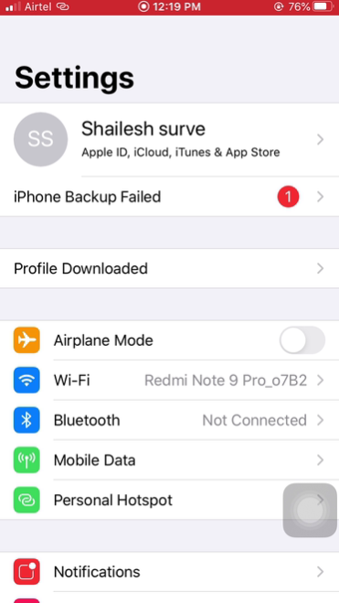

STEP 12:
Select Install
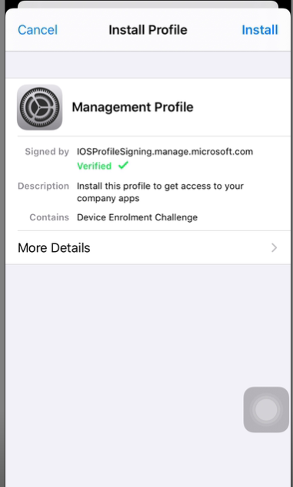

STEP 13:
Enter your Phone Passcode.

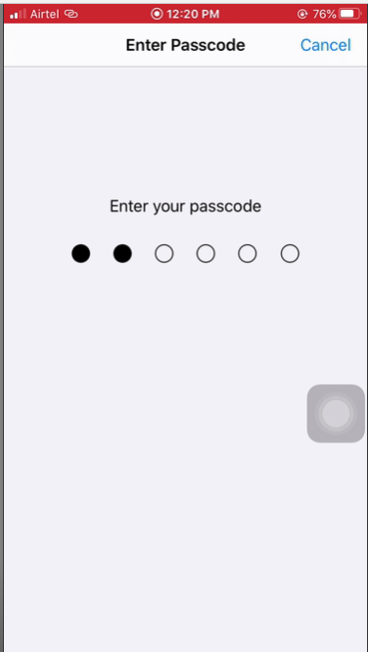

STEP 14:
Click on Install again.
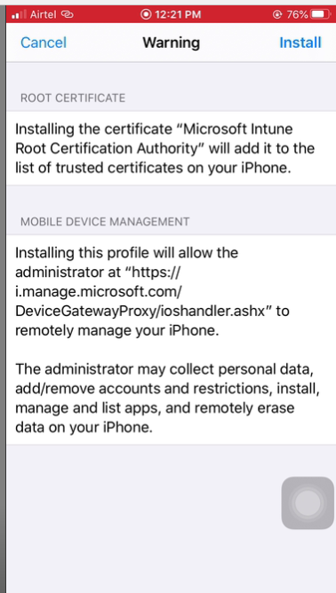

STEP 15:
Click on Trust
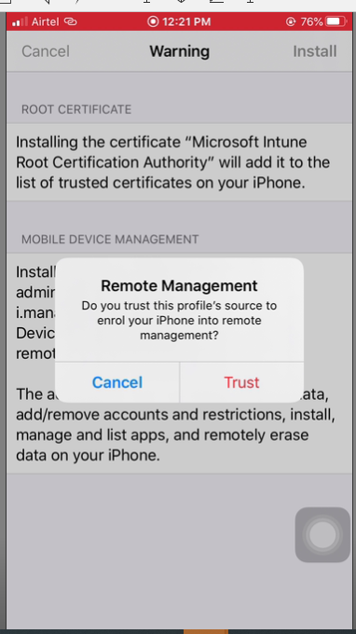

STEP 16:
Click on Done.
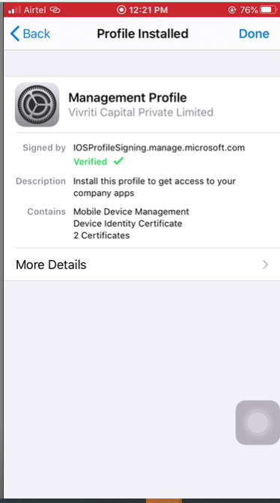

STEP 17:
Now Navigate to company Portal and click on Continue
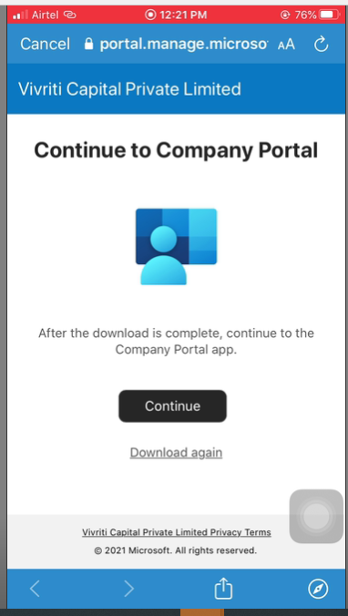

STEP 18:
Click on Done
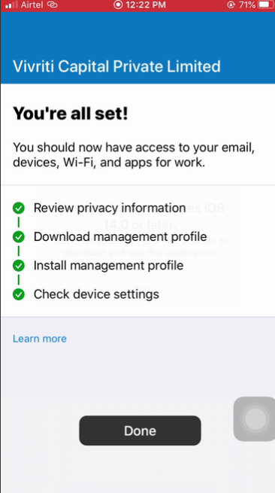

Now You will able to see the applications assigned to you.
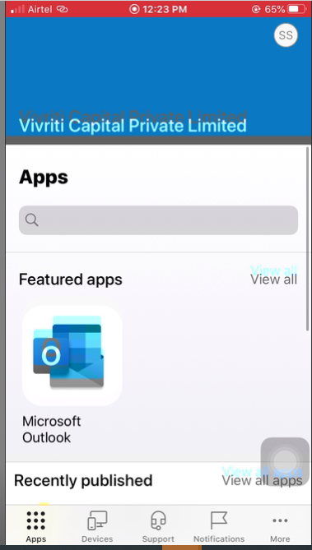
Select the application and click on Install.
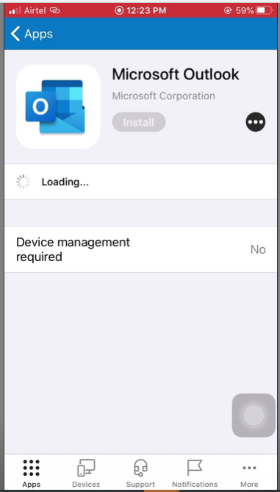
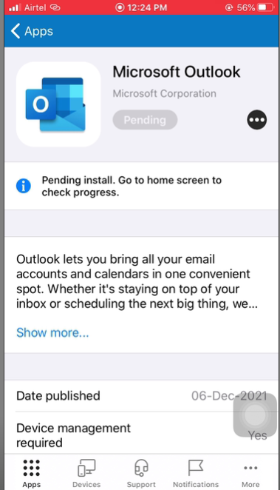s

